# General concept

General restaurant named “Ontbijtclub” a.k.a. Breakfast club. An MVC C# project with MySQL based database.

# Design and models

## (Simple) Class Diagram

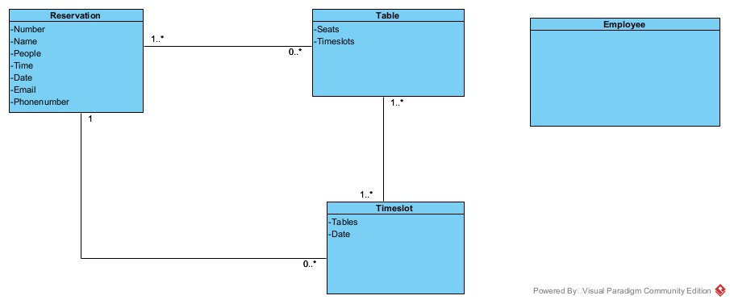

## Entity Relationship Diagram

